(City Management) Rest Api Crud Operation (Without DB)

1. Create New City
2. URL- <http://localhost:8080/api/city>
3. Method – POST

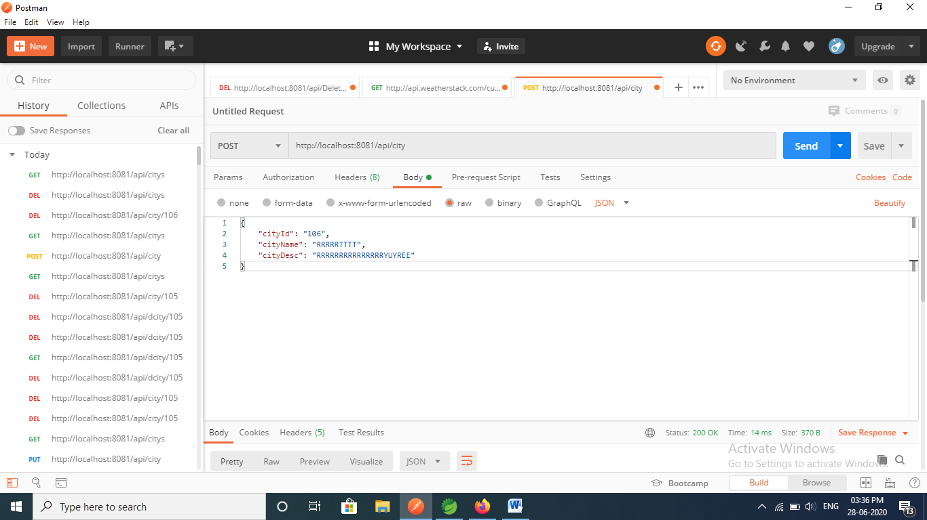

1. Get all City
2. URL - <http://localhost:8080/api/citys>
3. Method - GET

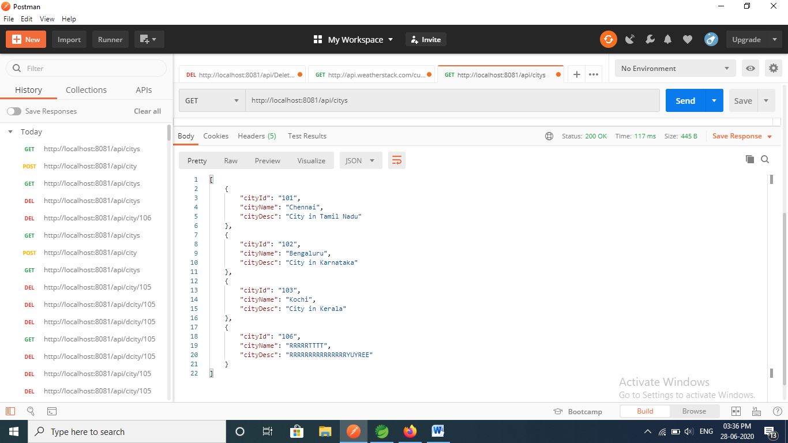

1. Get City by ID
2. URL - [http://localhost:8080/api/city/{cityid}](http://localhost:8080/api/city/%7bcityid%7d)
3. Method - GET

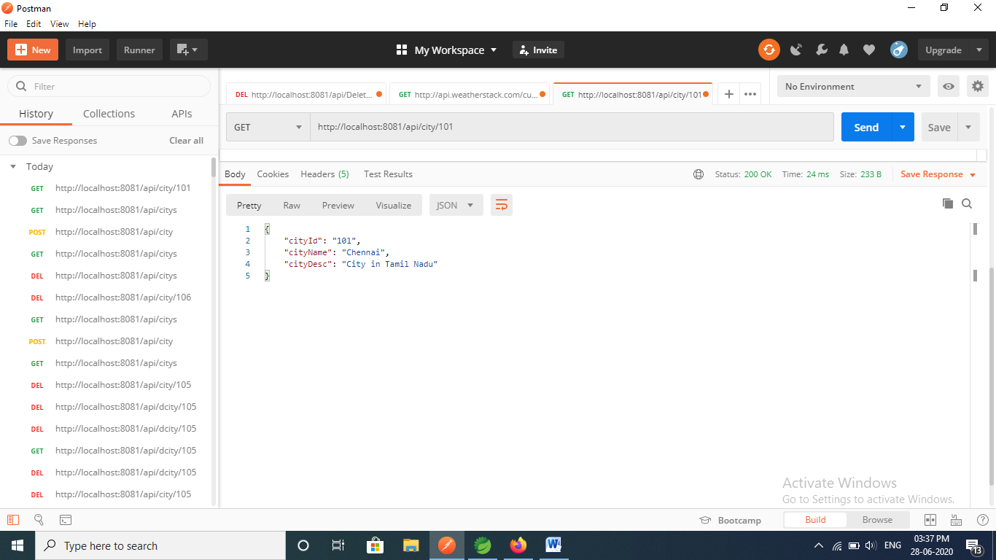

1. Update City
2. URL - <http://localhost:8080/api/city>
3. Method – PUT

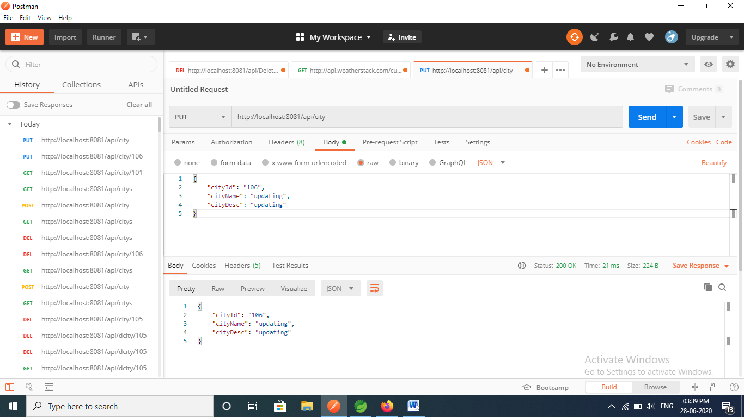

1. Delete City by ID
2. URL- [http://localhost:8080/api/city/{cityid}](http://localhost:8080/api/city/%7bcityid%7d)
3. Method - DELETE

